PTA REFLECTIONS PROGRAM 2021-2022

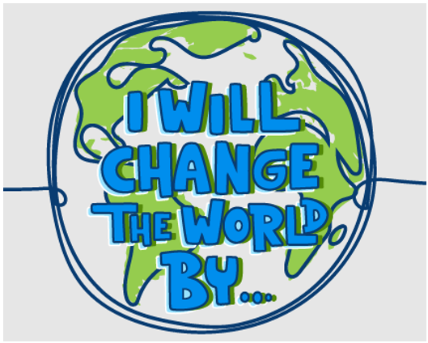

The Central Valley PTA is happy to again sponsor the 2021-2022 Reflections Program in our district. The Reflections program is an English and Arts contest in the following categories: Dance Choreography, Film Production, Literature, Music Composition, Photography, and Visual Arts.

This year’s theme is “I Will Change the World By…”

All students in Kindergarten through 5th grade are welcome to participate.

Deadline for entries is Friday, October 8th. All entries must be accompanied by the entry form which can be downloaded from the Central Valley PTA website: [www.centralvalleypta.org](http://www.centralvalleypta.org)

Please submit your entry and form to your teacher who will forward the entries to the PTA.

Student winners from the local level have the opportunity to move up through their district, region, council and state PTA programs to the national level.

Good luck to all entrants!